CryptInc
Scoring information

Score is calculated based on the number of tasks that a team will complete. Players cannot lose score for not completing tasks but can lose score if a teammate dies.
Score is calculated through task importance, meaning some tasks are worth more than others, ex. (Destroying the cryptids nest is worth more then a hair sample).

Scoring Tasks:
- Taking Pictures 2pts
- Hair samples 5pts
- Footprint casting 10-15pts
- Destroying nests 50pts
- Stunning cryptids with the flashlight 3pts
- Setting traps 2pts
- Setting up a base camp 25pts
- Perfect Mission Bonus (PMB). 40pts

*These points are subject to change. *
Taking Pictures is something that will be done frequently, depending on the quality of the picture you could potentially have a lower or higher point score.
Hair samples like the pictures can be based on species ex. (if you’ve collected a fox hair then it is worth less then a cryptid hair). Footprint casting can be based on species and quality, if the cast is a cryptid foot cast, then it could be worth 10-15 points based on how well it looks.
Destroying a nest is a big goal and will take some time, thus is the highest scoring task. Stunning the cryptid while not technically a task will reward the player with some points, as it puts them in danger. The cryptid will slowly become immune to this effect and so as it goes the points received will decreases as it loses its potency.
Setting traps will cause the cryptid to get stuck for a moment. Causing the player to have a small escape window and reward them with some points as well. Base camp would act as a van, separate from the van, as it is a safety zone, and a place you can bring your evidence. As such it takes a bit of time and rewards the player with a large sum of points.

Score Loss:

As mentioned previously score will be deducted when a player character dies. When a player character dies, they loss half of their points, the other people on the team lose 15% of their points based on each team member who dies. Players will not lose score for not completing tasks.

Perfect Mission Bonus (PMB):
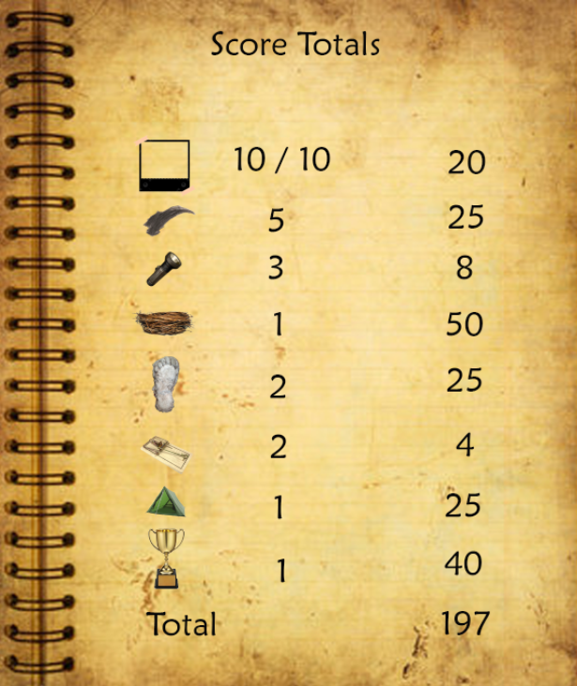
Players who survive to the end of the mission without dying will receive the perfect mission bonus, this will give the player or players who made it to the end without dying bonus points.

